**Exercise 6: Library Management System**

**Search Algorithms**

**Linear Search**

* Checks each item in the list one by one until the desired item is found or the list ends.
* **Works on unsorted data.**

**Binary Search**

* Repeatedly divides the sorted list into halves to find the item.
* **Works only on sorted data.**

**Output**

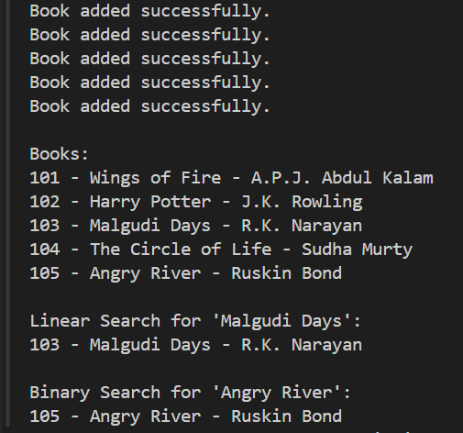

#### Time Complexity

* **Linear Search – O(n):**  
  Goes through each book until it finds the match.
* **Binary Search – O(log n):**  
  Cuts the search space in half each time, faster for large sorted lists.

#### When to Use

* **Use Linear Search:**  
  When data is small or unsorted.
* **Use Binary Search:**  
  When the list is large and already sorted.